Ilorin Innovation Hub – Monthly Report
Submitted to: IHS Nigeria
Reporting Period: June 2025
Submitted by: Managing Director
Date of Submission: 08/07/2025

1. Executive Summary

June 2025 marked a period of significant operational ramp-up and vibrant ecosystem engagement at the Ilorin Innovation Hub. The month featured a diverse lineup of programs, including the Enablers Mixer, two-part Dev Box sessions on Prompt Engineering, the Builder’s Path storytelling series, and the standout Kwara Kre8 creative workshop that inspired young creators and drew key industry voices. The month culminated in hosting the Kwara State Ease of Doing Business Initiative — a landmark, government-led reform workshop aimed at decentralizing business-friendly policies to local governments.

Operational milestones included the full resumption and onboarding of all 16 staff, completion of regulatory registrations, and progress on finance and banking infrastructure. Facility rentals, hospitality operations, and vendor coordination were actively managed alongside office administration and IT support functions. Content development, social media engagement, and system digitization via Zoho continued to grow in strength and structure.

A major incident during the month involved recurring roof leakages that caused minor flooding in parts of the facility, triggering urgent follow-up with the building contractors. Despite this, the team responded swiftly to mitigate the effects and ensure event continuity. Additionally, we developed a more practical, common-sense approach to managing the solar system during cloudy or high-usage periods, leveraging a new backup generator for safe system restarts and event support.

The month also saw strategic engagements with stakeholders such as MTN, IHS, and Amazon, strengthening future collaboration opportunities.

2. Programs & Events Report

Programs – June 2025

Enablers Mixer Ilorin – June 12th
A networking event to strengthen relationships among community enablers, founders, and ecosystem builders in Kwara State.

Dev Box 1: Prompt Engineering I – June 13th
Part 1 of a technical session under the Ilorin DevBox series, focused on how to effectively instruct AI using prompt engineering techniques. Targeted at students, business owners, and digital creatives.

KW-IRS Visit/Engagement – June 18th

Builder’s Path – June 18th
An interactive storytelling session that featured the entrepreneurial journey of Abdulrahman Jogbojogbo. Designed to spark a founder mindset and offer clarity on transitioning into venture building. Attendees included founders, product managers, student innovators, and enablers.

Kwara Kre8 – June 19th
A youth-focused creative workshop themed “Professionalising Nigeria’s Creative Industry,” featuring top speakers from government and the creative sector. It brought together photographers, content creators, and storytellers to explore monetisation, ethics, and industry opportunities. A standout moment was when 14-year-old Niniola received spontaneous pledges of support from guest speakers.

Dev Box 1: Prompt Engineering II – June 20th
Part 2 of the Ilorin DevBox series, continuing the focus on AI interaction, prompt crafting, and digital product design.

Masterclass with Dapo Adelegan – June 21st
A bold entrepreneurship masterclass that challenged participants to confront limiting beliefs, embrace ambitious thinking, and balance risk with disciplined execution. Attendance included business owners, government staff, and professionals — 50 in-person and 67 virtual.

Ministry of Finance – Ease of Doing Business Initiative (in collaboration with Ministry of Justice) – June 30th to July 7th
A week-long government-led workshop hosted at the Ilorin Innovation Hub by the Kwara State Ease of Doing Business Council (EODBC), bringing together stakeholders to roll out reforms such as digitized land titles, automated permits, MSME data systems, Small Claims Courts, and improved tax processes — all aimed at decentralizing reforms and boosting local economic activity.

Further detail available in attached Program Report.

3. Operations Report

3.1 Finances
- Successful activation & opening of two new accounts for the hub:
  - Zenith Bank (for hospitality & event refreshment revenue)
  - Sterling Bank (for facility rental revenue)
- Zenith & Sterling bank accounts have received inflow for some facility rentals but no access to the accounts has been activated yet.
- Mandate on accounts requested but yet to be fully activated
  - Finance Associate is transaction initiator
  - Managing Director & Director of Programs are signatories/approvers
  - Transactions over N500,000 require joint approval
  - Transactions under N500,000 can be approved by either of the two signatories
- Premium Trust (initial bank opened for IHS inflow) showing a bit of tardiness in handling requests, others seem responsive so far. We have made requests for the corporate internet banking with approval layers, email and SMS alerts and change of address which have not been granted, even though they keep telling us they’ve been treated at the head office.

Expenditure
June Expenses N28-30m
This is under reconciliation review across our various accounts and financial software, and will be sent in separately. Some expenses went out of central account with revenue coming in through other bank accounts. Backlog of salaries in March and April were also paid in June.

3.2 Administration
Front Desk & Office Support
- Oversight of Front Desk Support Staff including one corper. Proper orientation of guest welcoming and direction to relevant part of facility.
- Receipt of correspondence and conversion into digital format supporting our drive towards sustainability and paperless operations.
- Purchase of stationery and office supplies for entire office
Vendor Management
- Production of souvenirs for Staff – power bank, t shirts, mugs, notepads and pens
- Production of souvenirs for Programs – CCHub Roadshow (hand fans, t shirts, roller banners etc) in coordination with Graphics & Visual Designer. The cost of these items (N4m+ so far) were not planned or budgeted for, so they have eaten into the operational funds.
- Coordination of cleaning vendor along with Facility Manager, with focus on aesthetics and pleasant aroma across building.
Hospitality
- Hosting of important guests – IHS/Amazon, NACCIMA Conference delegation (over 100 guests), LCCI and other Kwara State dignitaries & stakeholders
- Procurement of hospitality items and supplies for VIP lounge
- Engagement and management of food vendors for events
- Coordination of event refreshments
Supporting VIP & MD Guests
- Coordinating general enquiries at front desk and hosting of guests
- Coordination of MD event invitations and appointment scheduling
Facility Rentals
- Coordination of inquiries for facility bookings (Halls, workspaces, meeting room and private offices) and processing of invoicing along with Finance, receipt of payment and refund of security deposits.
- Event planning & coordination with Facility Manager

3.3 Human Resources (HR)
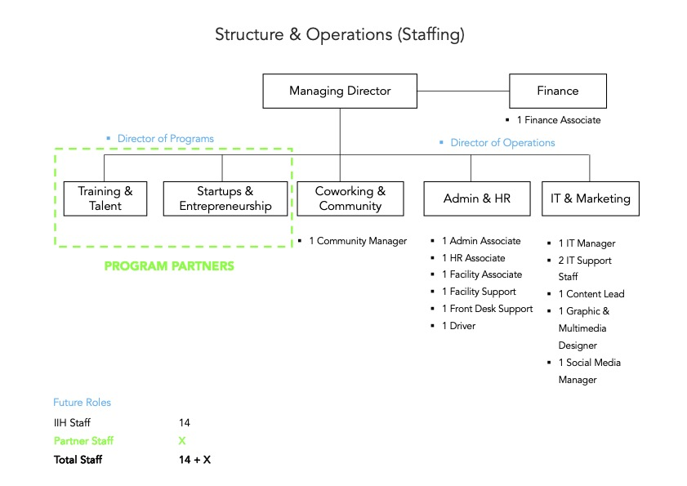
Hiring & Staffing
- Completion of Hiring Exercise – 16 staff in Total fully resumed with last member of staff, Community Manager resumed on June 15
- Completion of Staff Onboarding including staff NDA
- Staff Policies and Handbook ongoing
- Staff Training Material preparation ongoing and scheduled for week of July 14.
- Coordination and placement of interns & corpers across various units – IT Support, Facility Management & Front Desk
Compliance
- Registration with regulatory bodies completed: ITF, NSITF, PENCOM.
- Remittances done for ITF, NSITF
- Ongoing registration with KW-IRS with tax funds fully intact and awaiting organization onboarding with staff nominal roll, awaiting some staff TIN registration that has delayed
Welfare & Benefits
- Signup with HMO (Leadway Health) completed
- Pension plan onboarding on-going. Staff with previous pension plans fully onboarded awaiting those with new plans
- Group Life onboarding ongoing

3.4 Facility Management & Infrastructure
Facility
- Commencement of Outdoor Landscaping & Fumigation of Indoor/Outdoor of Hub
- Commencement of Professional Cleaning
- Completion of full hub inventory including electronics, furniture, appliances and other items. Submission with Finance done and sync ongoing
- Fixing of broken door locks and furniture
- Addition of hand bidets to all toilets within facility
- Maintenance of plumbing leaks and damage in toilets
- Purchase of small 10kva generator to fix restarting solar system after shutdown issue which still exists. Will also be available for event backup use and rental
- Purchase and installation of 1HP AC for maintenance office in utility building outside main building
- Activation of second gate and purchase of additional security locks
- Purchase of foosball table and board games for upstairs game lounge
- Renewal of facility DSTV subscriptions
- Purchase of external 240l waste bins, still pending purchase of larger 1100l waste bin which has not been available within Ilorin
- Management of Solar System and usage of power within the facility during work hours, events and dull/rainy periods with low sunlight.

Security
- Resumption of Security Personnel (9 guards) – We absorbed 3 of the older experienced security guards who had been guarding the hub for months for continuity
- Purchase of supporting security apparatus like walkie talkies due to need for instant communication in large facility compound
Incidents
- On-going back and forth with MC&T over roof leakage. A few more areas identified, and Geniserve brought into the loop to coordinate fixing. Roof leaks are still not completely resolved and seem to be increasing in number. We have called MC&T directly for urgent solution even if it requires new roofing sheets in leaking locations.
- Facility flooding due to high pressure of pressure pump which was activated to boost sprinklers. This was cleaned and handled with need to figure out best way to handle pressure pump.
- Fixing of outdoor security garden lights by MC&T contractor after attempt to fix with no solution.
- Minor flooding due to roof leakage across facility, which have all been identified and reported to building contractor MC&T

3.5 IT Support
General IT Support
- Processing & Activation of MTN fiber internet, awaiting deployment by July 22
- Installation & Activation of Starlink Internet for VIP Lounge and Management offices
- Procurement & Setup of Zoho Software applications for staff – Workplace, Books, People, Forms, Creator
- Successful fixing of LED screen in Main Hall damaged during rainstorm and roof leakage in May.
- Migration of ad-hoc processes and temporary records to Zoho software on-going
- Purchase of Staff Phones & MTN SIM lines with CUG activation
- Purchase of Front Desk land phone for IIH – 0700 7000 IIH also part of staff CUG

Event Support
- Successful support of all events including audio visual and sound and occasional live streaming
- Support with projectors in workshop style events.
Content & Social Media
- Design of all event banners and promo material
- Design of internal documents and correspondence
- Capturing of event photos and posting to all social media platforms – Instagram, Facebook, Twitter, LinkedIn and most recently Tik Tok.
- Development of content strategy for the hub, including individual approach for each platform
- Ongoing development of Community Newsletter on Zoho platform

3.6 Managing Directors Office
- Supervision of two main arms of organization – Programs & Operations while playing role of Director of Operations
- Engagement of stakeholders within & outside Kwara State
- Attendance of MTN Datacentre Launch along with IT Manager on their invitation, solidifying relationship with MTN and exploring opportunities with their new cloud data infrastructure and Startup Accelerator program.
- Supervising responses to daily inquiries and messages via email and social media platforms usually requesting for partnership, job placement, internship, inquiries about space usage.
- Receiving important visitors and taking them on tour of the hub when available
- Completion & distribution of Staff Core Values ahead of Staff Training
- Regular checkups with Heads of Units on work progress and outstanding tasks

4. Conclusion
The Ilorin Innovation Hub continues to gain momentum as both a functional facility and a strategic node for innovation and digital development in Kwara State. June’s activities underscore our growing convening power and ability to attract both grassroots and institutional stakeholders.
While progress has been steady, certain areas require further attention—particularly resolving persistent roof issues with MC&T, activating corporate internet banking across all accounts, and closing out ongoing compliance registrations. Financial reconciliation is also underway and will be submitted separately.
As we enter the next operational quarter, our focus will shift to consolidating internal systems, optimizing our space management, and accelerating ecosystem-facing programming in alignment with our strategic partners.

